An online payment system that allows transaction without using a financial institution is a new and efficient way of transaction. While the system works well enough for most transactions it still suffers from trust-based issues. Merchants must be wary of their customers, hassling them for more information than they would otherwise need. Digital signatures provide part of the solution, but the main benefits are lost if a trusted third party is still required to prevent double-spending. No mechanism exists to make payments over a communications channel without a trusted party. What is needed is an electronic payment system based on cryptographic proof instead of trust, allowing any two willing parties to transact directly with each other without the need for a trusted third party.

We define an electronic coin as a chain of digital signatures. Each owner transfers the coin to the next by digitally signing a hash of the previous transaction and the public key of the next owner and adding these to the end of the coin. A payee can verify the signatures to verify the chain of ownership. The problem of course is the payee can't verify that one of the owners did not double-spend the coin. A common solution is to introduce a trusted central authority, or mint. The problem with this solution is, with every transaction having to go through them, it is just like a bank. We need a way for the payee to know that the previous owners did not sign any earlier transactions. For this purpose, the earliest transaction is the one that counts, so we don't care about later attempts to double-spend. The only way to confirm the absence of a transaction is to be aware of all transactions. To accomplish this without a trusted party, transactions must be publicly announced, and we need a system for participants to agree on a single history of the order in which they were received. The payee needs proof that at the time of each transaction, the majority of nodes agreed it was the first received.

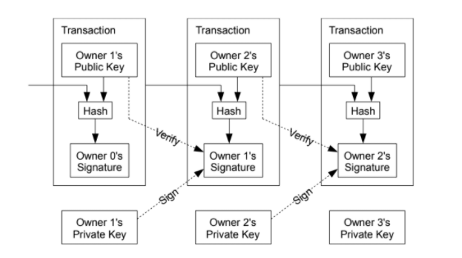

The solution we propose begins with a timestamp server. A timestamp server works by taking a hash of a block of items to be timestamped and widely publishing the hash, such as in a newspaper or Usenet post. The timestamp proves that the data must have existed at the time, obviously, in order to get into the hash. Each timestamp includes the previous timestamp in its hash, forming a chain, with each additional timestamp reinforcing the ones before it.

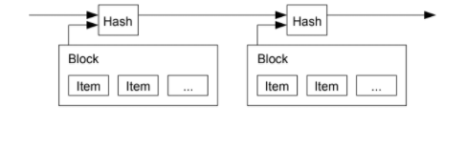

To implement a distributed timestamp server on a peer-to-peer basis, we will need to use a proof- of-work system similar to Adam Back's Hashcash, rather than newspaper or Usenet posts. The proof-of-work involves scanning for a value that when hashed, such as with SHA-256, the hash begins with a number of zero bits. The average work required is exponential in the number of zero bits required and can be verified by executing a single hash. For our timestamp network, we implement the proof-of-work by incrementing a nonce in the block until a value is found that gives the block's hash the required zero bits. Once the CPU effort has been expended to make it satisfy the proof-of-work, the block cannot be changed without redoing the work. As later blocks are chained after it, the work to change the block would include redoing all the blocks after it. The proof-of-work also solves the problem of determining representation in majority decision making. The majority decision is represented by the longest chain, which has the greatest proof-of-work effort invested in it.

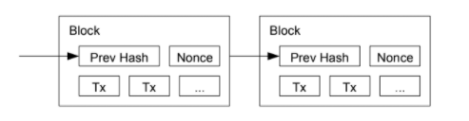

The steps to run the network are as follows:

1) New transactions are broadcast to all nodes.

2) Each node collects new transactions into a block.

3) Each node works on finding a difficult proof-of-work for its block.

4) When a node finds a proof-of-work, it broadcasts the block to all nodes.

5) Nodes accept the block only if all transactions in it are valid and not already spent.

6) Nodes express their acceptance of the block by working on creating the next block in the

chain, using the hash of the accepted block as the previous hash.

Nodes always consider the longest chain to be the correct one and will keep working on extending it. If two nodes broadcast different versions of the next block simultaneously, some nodes may receive one or the other first. In that case, they work on the first one they received, but save the other branch in case it becomes longer. The tie will be broken when the next proof-of-work is found and one branch becomes longer; the nodes that were working on the other branch will then switch to the longer one.

It is possible to verify payments without running a full network node. A user only needs to keep a copy of the block headers of the longest proof-of-work chain, which he can get by querying network nodes until he's convinced, he has the longest chain, and obtain the Merkle branch linking the transaction to the block it's timestamped in. He can't check the transaction for himself, but by linking it to a place in the chain, he can see that a network node has accepted it, and blocks added after it further confirm the network has accepted it. As such, the verification is reliable as long as honest nodes control the network, but is more vulnerable if the network is overpowered by an attacker. While network nodes can verify transactions for themselves, the simplified method can be fooled by an attacker's fabricated transactions for as long as the attacker can continue to overpower the network. One strategy to protect against this would be to accept alerts from network nodes when they detect an invalid block, prompting the user's software to download the full block and alerted transactions to confirm the inconsistency. Businesses that receive frequent payments will probably still want to run their own nodes for more independent security and quicker verification.

